***Directions:*** Display a snippet of the code and the output below:

**COP2335: Object-Oriented Programming Lab 5**

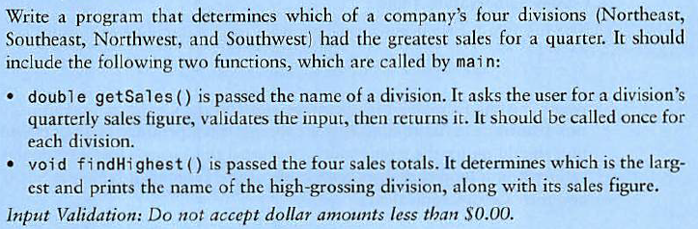**Snippet of the Code:**

**Snippet of the Output:**

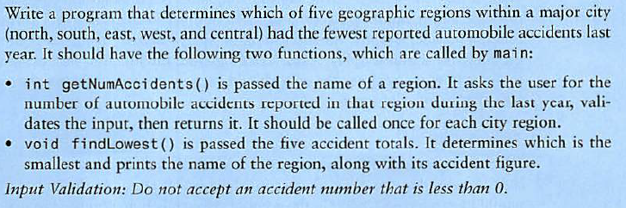**Snippet of the Code:**

**Snippet of the Output:**

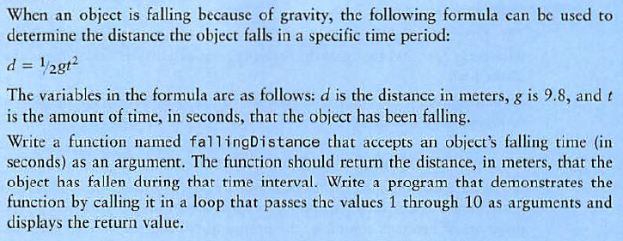**Snippet of the Code:**

**Snippet of the Output:**

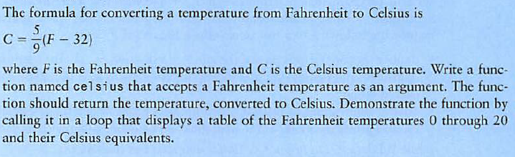**Snippet of the Code:**

**Snippet of the Output:**

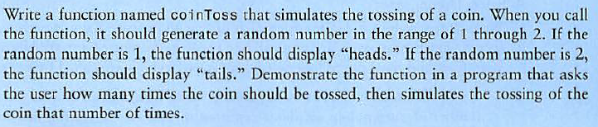**Snippet of the Code:**

**Snippet of the Output:**

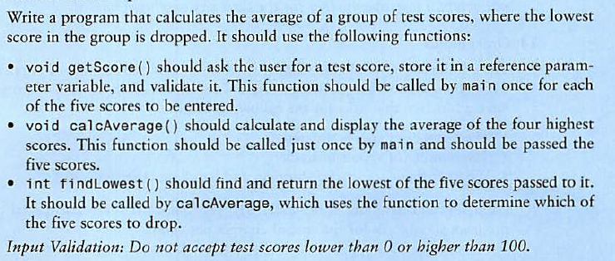**Snippet of the Code:**

**Snippet of the Output:**

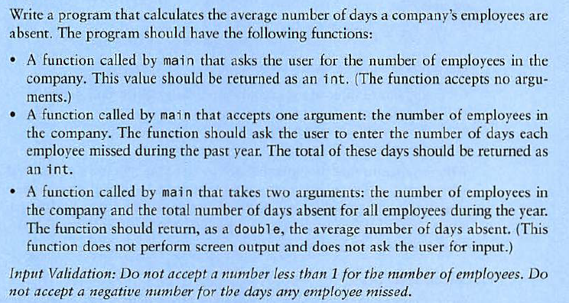**Snippet of the Code:**

**Snippet of the Output:**

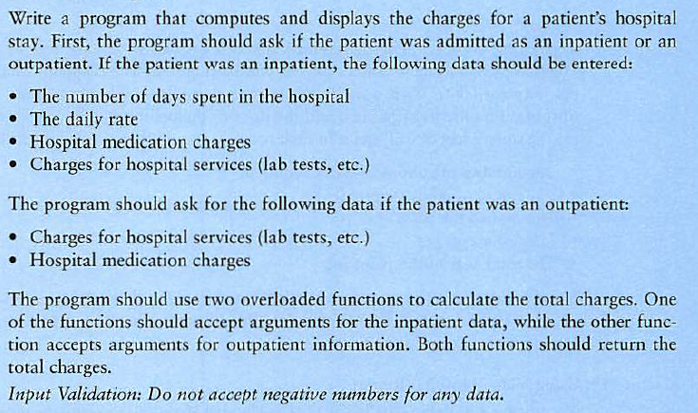**Snippet of the Code:**

**Snippet of the Output:**

